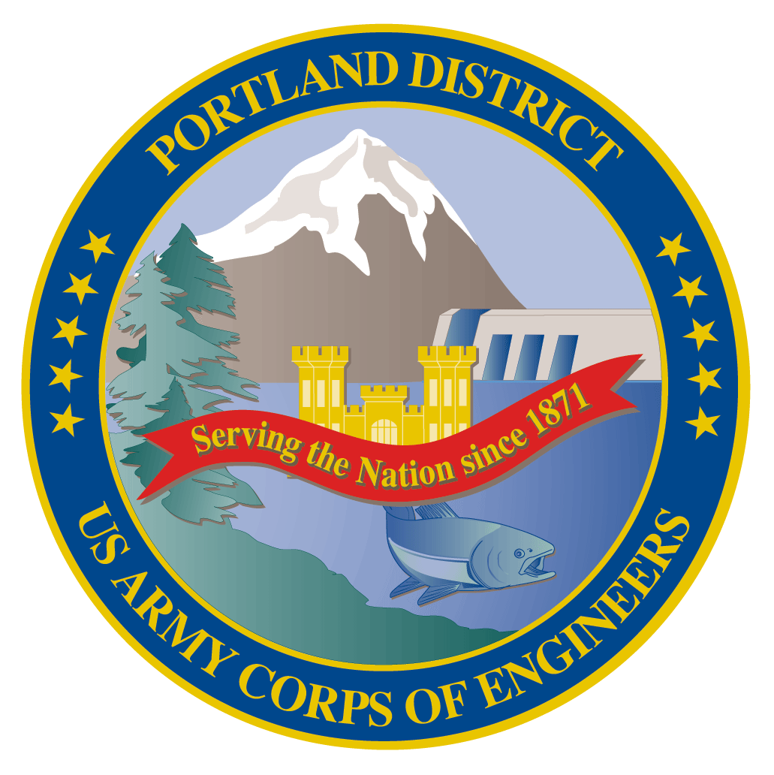
Lower Columbia River Fish Facility Design Review Work Group (FFDRWG)

USACE, Portland District
  - October 2022 Notes
Meeting Date: October 6, 2022, 09:00-11:00
Join Meeting: https://usace1.webex.com/join/jacob.macdonald
Join by phone (audio only, no Webex): (844) 800-2712 | Access Code: 1995 00 9820

FFDRWG Meeting Files:
http://pweb.crohms.org/tmt/documents/FPOM/2010/FFDRWG/2022%20FFDRWG/

Introductions
FFDRWG members:
BPA
Scott Bettin
Kim Johnson
Christine Petersen
Greg Smith
Leah Sullivan
Ben Hausmann
NOAA
Blane Bellerud
Gabriel Brooks
Trevor Conder
Claire McGrath
Kelsey Swieca
USFWS
Dave Swank
Shelby Fowler
States
Erick Van Dyke (ODFW)
Charles Morrill (WDFW)
Jonathan Ebel (IDFG)
CRITFC/Tribes
Tom Lorz (CRITFC)
Blaine Parker (CRITFC)
Tom Skiles (CRITFC)
Laurie Porter (CRITFC)
Greg Silver (CRITFC)
Casey Baldwin (CTCR)
Michael Karnosh (CTGR)
Lawrence Schwabe (CTGR)
Torey Wakeland (CTGR)
Aaron Jackson (CTUIR)
Ralph Lampman (YN)
NPCC
Leslie Bach
Kris Homel
FPC
Erin Cooper
PSMFC
Alan Brower
Darren Chase
Roger Clark
Mark Leonard
Scott Livingston
Nicole Tancreto
Don Warf
CENWD
Doug Baus
Tim Dykstra
Dan Feil
Cindy Studebaker
Lisa Wright
Sean Tackley
CENWW
Chris Peery
Steve Juhnke
CENWP-OD
Andrew Derugin
Rebecca Cates
Jeanette Wendler
Tucker Gossett
Bob Cordie
Jeffrey Randall
Eric Grosvenor
Michael Lotspeich
Laura Rickets
Tammy Mackey
Robert Wertheimer
Patricia Madson
Darren Gallion
Kyle Tidwell
CENWP-PM
Jim Adams
Ian Chane
Jeff Hicks
Jeremiah Woodard
Erin Kovalchuk
Brad Eppard
Nathan McClain
Jake Macdonald
Jon Rerecich
Ida Royer
David Trachtenbarg
Scott Fielding
CENWP-ENC
Adam White
Brandt Bannister
Shari Dunlop
Chris Motti
Steve Schlenker
Max Wilson-Fey
Collin Porter
Dan Penn
Aaron Litzenberg
Mehdi Roshani
Cole Marfise

Action items from previous meetings

Topics for FFDRWG Discussion/Review/Coordination
- TDA adult lamprey passage improvements – Jeremiah Woodard (PM), Adam White (TL), Jake Macdonald (FC)
90% DDR available for FFDRWG review at FFDRWG Meeting Files
  - Bulkhead slot filler design – White/Porter
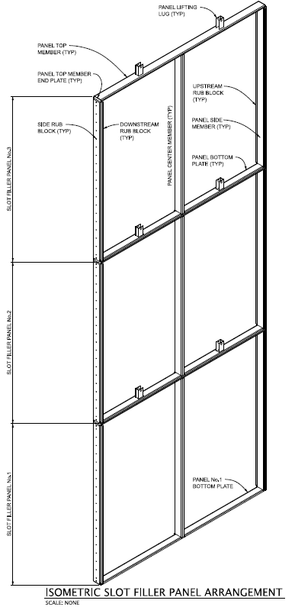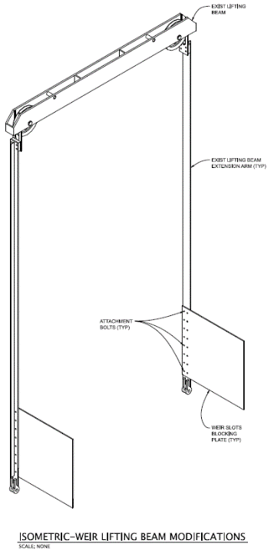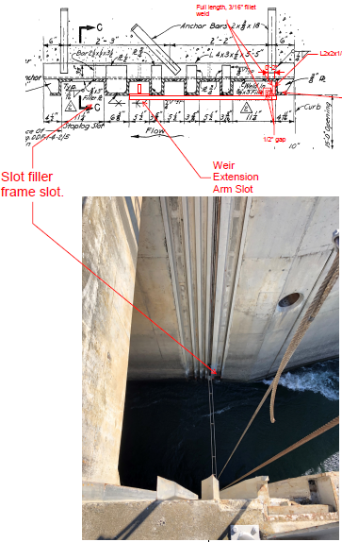
    - NOAA doesn’t like it. Do we have to impede the flow? Suggest we look into Inflatable technology, magnets. Mimic an entrance that works
    - from Laurie Porter to everyone: 9:27 AM Jake, can you send an email to the Lamprey workgroup and ask for suggestions?
    - Action: Jake will invite interested FFDRWG and LAW members to a brainstorming session with the PDT to try to come up with an alternate design.
    - Why can’t we do variable width (“keyhole”) entrance weirs at The Dalles? There was a reason, but no one remembers off the top of their head.
    - Action: Jake and Steve Schlenker will research why we think variable width weirs aren’t feasible at The Dalles and report back.
  - LPS Collection tank location – White/Penn
    - 90% LPS design has two ramps on either side of the EFL junction pool (cyan and green lines) that meet at a junction (blue blob) then continue along a horizontal traverse (faint red line) to a collection box in the parking lot under the ladder (red blob).
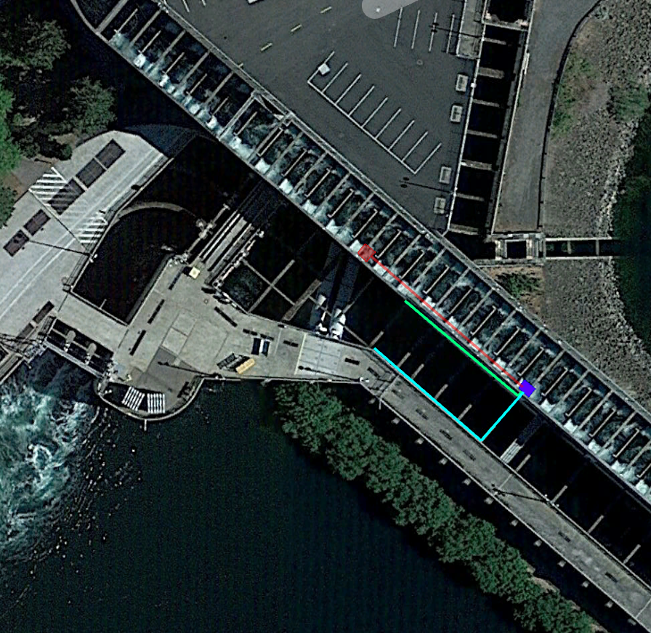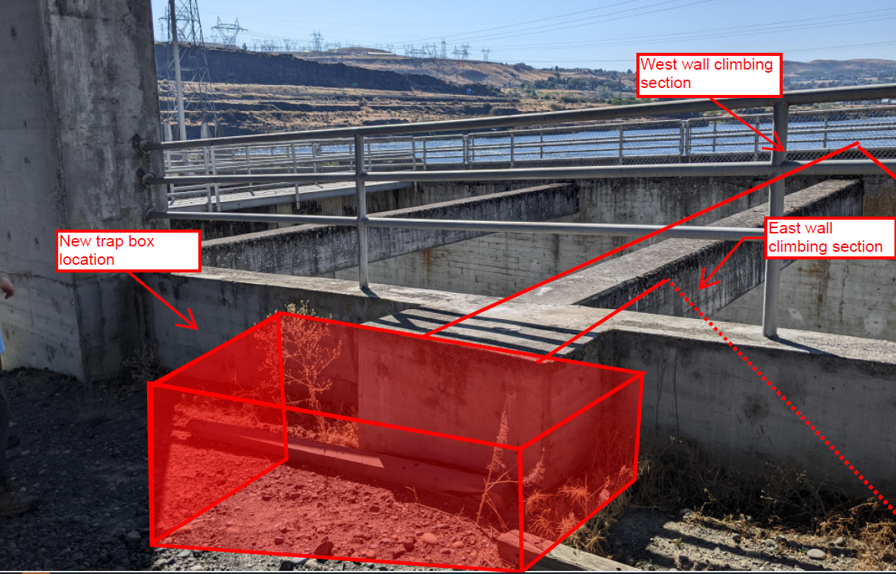
    - PDT is proposing to move the collection box from the parking lot to the location of the junction box, eliminating the long traverse section. This wasn’t possible before because we were originally looking at a very large collection box to support longer lamprey holding times at The Dalles. Long-term lamprey holding is no longer needed at The Dalles (according to the LAW) so we can use a more reasonably sized tank.
    - from Laurie Porter to everyone 9:43 AM Maybe email this new design to the LAW for comment? Jake: I have already sent these pictures to Greg Silver and Devayne Lewis for their input, will share with the rest of LAW when we have better drawings.
- TDA Backup AWS debris management – Erin Kovalchuk (PM), Mehdi Roshani (TL), Jon Rerecich (FC)
  - 50% EDR and ranking matrix are available for FFDRWG review at FFDRWG Meeting Files
  - Presentation of 60% alternatives – Roshani/Rerecich
    - See Roshani_TDA-AWS-Backup-Debris-Management_FFDRWG.pdf
    - 50% EDR has 20+ alternatives, 60% narrows it down to 2.
      - Alt. 10: new trash racks and matching rake
      - Alt. 11: a brush for the existing trash screens
    - 60% Alternatives Evaluation Report will be distributed for FFDRWG review in December-January
    - from Stephen Schlenker to everyone: 9:54 AM Passing river flow is normal eddy flow in upstream direction at intake.
    - from Jeff Randall to everyone: 9:55 AM it will have a boom reinstalled this IWWP
    - from Stephen Schlenker to everyone: 9:59 AM I thought it was 4000 valve cycles life.
    - from Jeff Randall to everyone: 10:07 AM BC 's understanding is 1400...he explained it's actually 700 cycles, the 1400 # is for one motion, open =1 & closed =1
    - from Stephen Schlenker to everyone: 10:07 AM Thanks for the correction.
    - from Jeff Randall to everyone: 10:43 AM TD fisheries speculate a brush, rake, air bubbler would only need to be 12-20' as the debris impinges only that top portion of the water column. we came to this conclusion via our observation of the debris wad float out and away and immediate differential is resorted.
- Other topics
  - John Day Ladder Cooling
    - Continue discussion of available data and development of a recommendation for the 2025 budget capability submission in November 2022 – Lotspeich/Macdonald
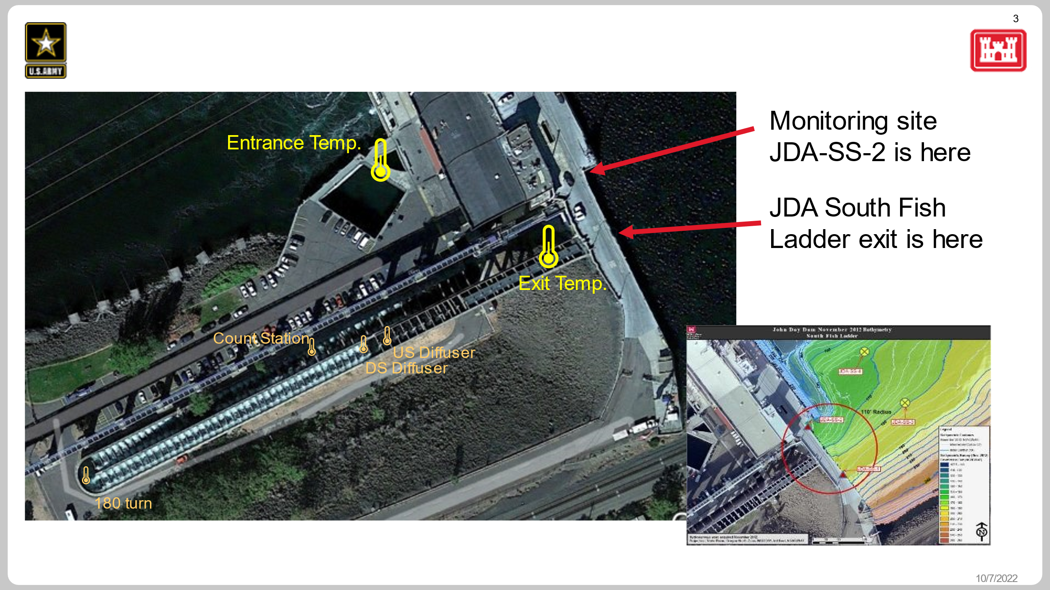
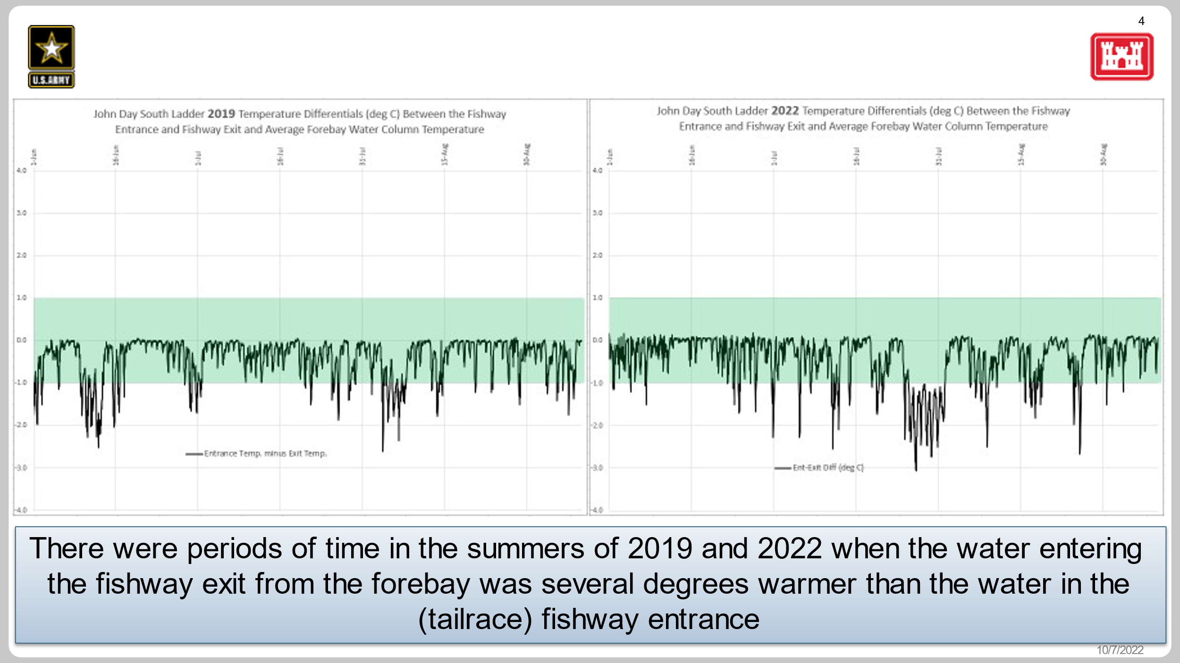
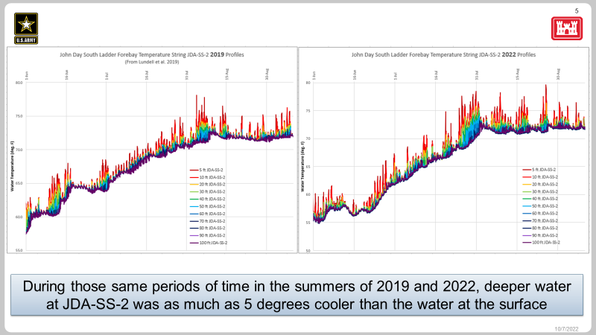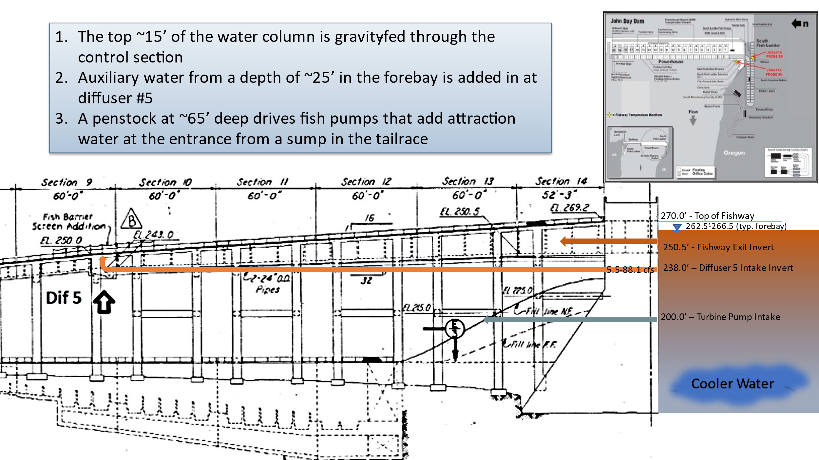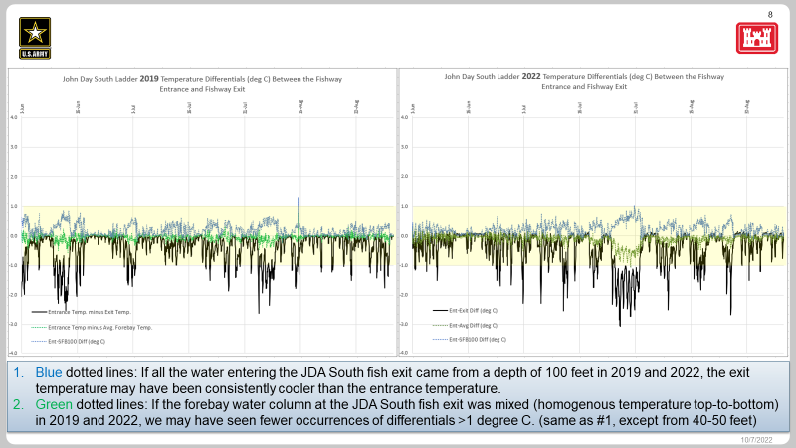
    - Lotspeich showed some very preliminary results from the shad mode test that suggest a slight cooling effect at diffuser 5 from increased diffuser flow.
      - This test was not rigorous enough to draw any real conclusions from but the results are encouraging for supporters of temperature control.
    - Corps is finalizing a memo summarizing temperature conditions in the JDA South Fish Ladder and the results of the shad mode test.
      - Add air temp as a contributing variable
    - Action: Scott Fielding will send the JDA temperature memo to FFDRWG the week of October 17th and lead discussions about the memo and our recommended path forward at the November FFDRWG meeting.
  - BON Spillway rock removal & prevention – Erin Kovalchuk (PM), Max Wilson-Fey (TL), Jake Macdonald (FC)
    - completed Phase 1A report (similar to an EDR) in January 2022.
    - project has been shelved awaiting funding for Phase 1, may be provided at the beginning of FY23.
    - “BON Spillway Rock Mitigation Phase 1A Final Report” available at FFDRWG Meeting Files
    - Was there an MOC about damage to the stilling basin from rocks this year?
    - from Becca Cates: B-Branch apron erosion due to spillway forebay flushing is still being analyzed. They performed an ROV with inconclusive results and a follow-up hydrosurvey last Friday Sept 30 and results are still pending.
  - Questions on written updates?
    - Tom Lorz: Weren’t we going to talk about B2 FGE? Jon Rerecich: No, it’s all in the written update.

Written Updates
JDA adult lamprey passage improvements 3
TDA adult lamprey passage improvements 4
BON1 adult lamprey passage improvements 4
BON2 adult lamprey passage improvements 6
BON Second Powerhouse FGE 8
TDA Backup AWS Debris Management EDR 9
JDA Ladder Cooling 11

Fish Facility Design Review Work Group (FFDRWG)
USACE, Portland District
Project Update
Date Prepared/Updated: 2022-08-31

JDA adult lamprey passage improvements
Project Identifier: | P2 # 492402
Project Manager (PM): | Jeremiah Woodard (CENWP-PMF)  jeremiah.j.woodard@usace.army.mil
Technical Lead (TL): | Adam White (CENWP-ENC)  Adam.J.White@usace.army.mil
FFDRWG Coordination (FC): | Scott Fielding (CENWP-PME)  Scott.D.Fielding@usace.army.mil

Project Description

Modify NFL LPS to increase the capacity and reliability of the system
This is a fish safety/health issue, and the upgrade needs to happen. Current water supply is insufficient so tank cannot be installed without upgraded water supply. See January 2020 CRS BA § 2.5, pg. 2-85.
- gravity-fed water supply or alternative, more reliable pump configuration.
- larger collection box

SFL entrance improvements (rounded crest, slot cover/filler)
Caps may not be able to be added to South Ladder entrance weir due to FPP submergence criteria, so the weir may need to be modified more extensively to provide rounded weir crests and guide slot covers.

SFL count station collection and counting structure (trap) improvements
Increase capacity and efficiency of system by preventing sediment buildup, providing a larger opening into a larger collection box, modified guide, and removal of gate and counting-related structure.

Project Schedule
Design: FY 2021 – FY 2022
30% DDR – July 2021
60% DDR – November 2021
100% DDR – May 2022
Construction: December 2022 - March 2023
Evaluation/Closeout: FY 2023

Current Status
100% DDR is complete. PDT is moving forward with a gravity feed water supply from behind existing picketed leads near the count station via an existing diffuser drain line. A surplus holding tank at JDA will be modified and relocated to serve as the larger collection box. All work will be performed by Corps staff, no contracts.

Topics for FFDRWG Review/Coordination
100% JDA DDR is available on the FFDRWG meeting files website. Because it’s an in-house construction project, there will be no 90% DDR and no BCOES, PDT is advancing straight from 60% to 100%.

Fish Facility Design Review Work Group (FFDRWG)

USACE, Portland District

Project Update
Date Prepared/Updated: 2022-08-31

TDA adult lamprey passage improvements
Project Identifier: | P2 # 492403
Project Manager (PM): | Jeremiah Woodard (CENWP-PMF)  jeremiah.j.woodard@usace.army.mil
Technical Lead (TL): | Adam White (CENWP-ENC)  Adam.J.White@usace.army.mil
FFDRWG Coordination (FC): | Jacob Macdonald (CENWP-PME)  Jacob.Macdonald@usace.army.mil

Project Description

Lamprey collection system (LPS) at the east fish ladder junction pool
Provide two ramps for lamprey to swim out of the junction pool and into a collection box located below the upper segment of the fish ladder for upstream transport. See January 2020 CRS BA § 2.5, pg. 2-85.

Modify elevated orifices in EFL exit weirs 154-157
Provide better lamprey passage options through the 4 control weirs at the upstream end of the east fish ladder.

Bulkhead slot covers
Design and install bulkhead slot covers at all four fishway entrances.

Project Schedule
Design: FY 2021 – FY 2023
30% DDR – August 2021
60% DDR – February 2021
90% DDR – September 2022
BCOES – November 2022
Construction: December 2023 - March 2024
Evaluation/Closeout: FY 2024

Current Status
90% DDR is underway. Preferred LPS design includes gravity-fed water supplied from an existing auxiliary penstock in the dam, a large collection box on the deck near the junction pool, and two climbing ramps reaching down to the fishway floor.

Topics for FFDRWG Review/Coordination
- Exit weirs 154-157 will be notched in the corners to improve lamprey passage. Because the weirs have lead paint, they will be removed from the ladder to perform this work. Project will perform the necessary lead paint mitigation away from the fish ladder.
60% TDA DDR is available on the FFDRWG meeting files website. 90% will be available in September.

Fish Facility Design Review Work Group (FFDRWG)

USACE, Portland District

Project Update
Date Prepared/Updated: 2022-08-31

BON1 adult lamprey passage improvements
Project Identifier: | P2 # 492400
Project Manager (PM): | Jeremiah Woodard (CENWP-PMF)  jeremiah.j.woodard@usace.army.mil
Technical Lead (TL): | Adam White (CENWP-ENC)  Adam.J.White@usace.army.mil
FFDRWG Coordination (FC): | Jacob Macdonald (CENWP-PME)  Jacob.Macdonald@usace.army.mil

Project Description
The project scope is divided into three parts:

Entrance Modifications
Modify the B-branch fish ladder entrance to improve lamprey passage. This includes a variable-width entrance weir with rounded edges, guide slot fillers or covers to aid lamprey passage along the walls, and bollards on the channel floor for hydraulic refuge.

Lamprey Collection
Provide an alternate route for lamprey entering the B-branch of the Bradford Island fish ladder. Fish would climb up a flume structure to a holding tank on the deck of the dam and be transported upstream by Tribal fisheries personnel. This will be designed so that in the future we could extend the system to provide volitional passage to the Bonneville forebay.

Serpentine Section Extensive Minor Mods
Upgrade the serpentine section of the Bradford Island fish ladder to improve lamprey passage by rounding corners, providing refuge boxes, and lamprey orifices.

Project Schedule
Design: FY 2021 – FY 2022
30% DDR – July 2021
60% DDR – November 2021
90% DDR – August 2022
BCOES – October 2022
Construction:
Advertise Contract – January 2023
Award Contract – April 2023
Installation - December 2023 - March 2024
Evaluation/Closeout: FY 2024 - FY 2025

Current Status
90% DDR is underway. PDT is refining the LPS climbing flume alignment.

Topics for FFDRWG Review/Coordination
60% BON1 DDR is available on the FFDRWG meeting files website.

Fish Facility Design Review Work Group (FFDRWG)

USACE, Portland District

Project Update
Date Prepared/Updated: 2022-10-03

BON2 adult lamprey passage improvements
Project Identifier: | P2 # 492401
Project Manager (PM): | Jeremiah Woodard (CENWP-PMF)  jeremiah.j.woodard@usace.army.mil
Technical Lead (TL): | Shari Dunlop (CENWP-ENC)  Shari.L.Dunlop@usace.army.mil
FFDRWG Coordination (FC): | Nathan McClain (CENWP-PME)  nathan.a.mcclain@usace.army.mil

Project Description
Full redesign of control section (EDR/DDR, P&S, Construction).
2020 CRS BA Chapter 2: Proposed Action (pg.2-85): “This measure would modify the serpentine-style flow control sections of Bonneville Dam’s Washington Shore and Bradford Island fish ladders, converting them to Ice Harbor-style vertical slot with submerged orifices configurations. This would improve passage conditions for adult lamprey and likely reduce stress and delay for adult salmon, steelhead, and bull trout.” All full-duplex passive integrated transponder (PIT) arrays currently located in the control sections of these ladders would be replaced in kind or improved to maintain or enhance current levels of detection of PIT-tagged anadromous fish.

Project Schedule
Design: FY2021-FY2024
Construction: Winter 2024/2025
Evaluation/Follow-on: FY2025-FY2026
Closeout: FY 2027
Preliminary Milestones:
- Project Kick-Off: ~ August 2021
- 30% DDR: ~ January 2021
- 60% DDR: ~ June 2022 *FFDRWG review ~August 2022
- 90% DDR: ~ January 2023 *FFDRWG review ~February 2023
- Draft-Final: ~ February 2023 *FFDRWG review ~February/March 2023
- [Start P&S after 90% DDR DQC is complete, ~February 2023]

Current Status
The 60% DDR has gone through USACE internal (DQC) and external (ATR) reviews and was made available for FFDRWG review in August 2022. The PDT is currently addressing review comments, refining the layout and adding detail to the design. The PDT has validated the computational fluid dynamics (CFD) models to field-collected data and are using the models to simulate the hydraulic conditions for the existing and proposed control section. The PDT continues to coordinate with PSMFC to incorporate provisions for the new PIT antenna arrays into the design.

Topics for FFDRWG Review/Coordination
60% BON2 DDR is available on the FFDRWG meeting files website. No specific coordination items anticipated this month.
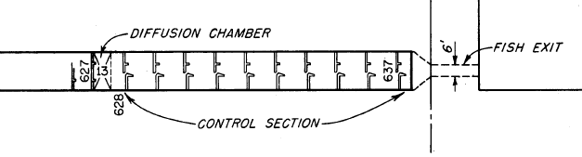
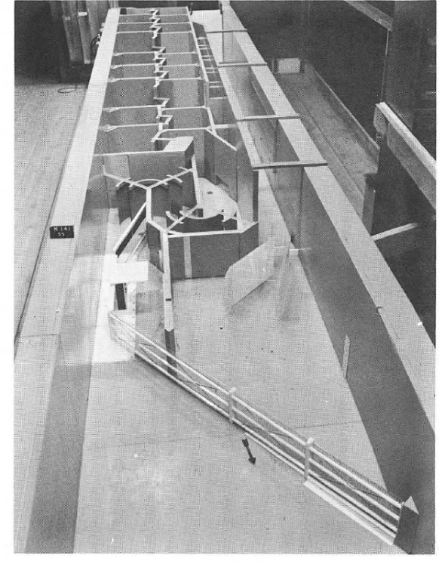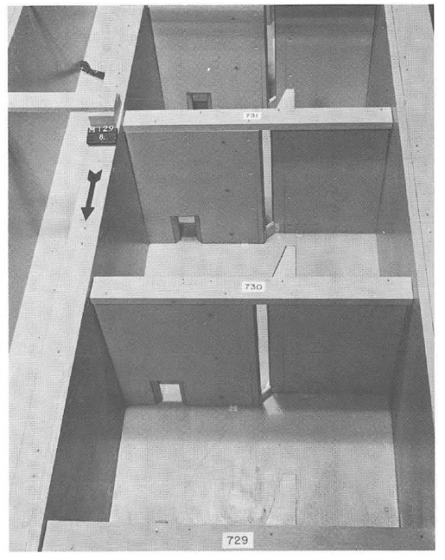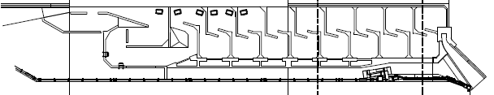
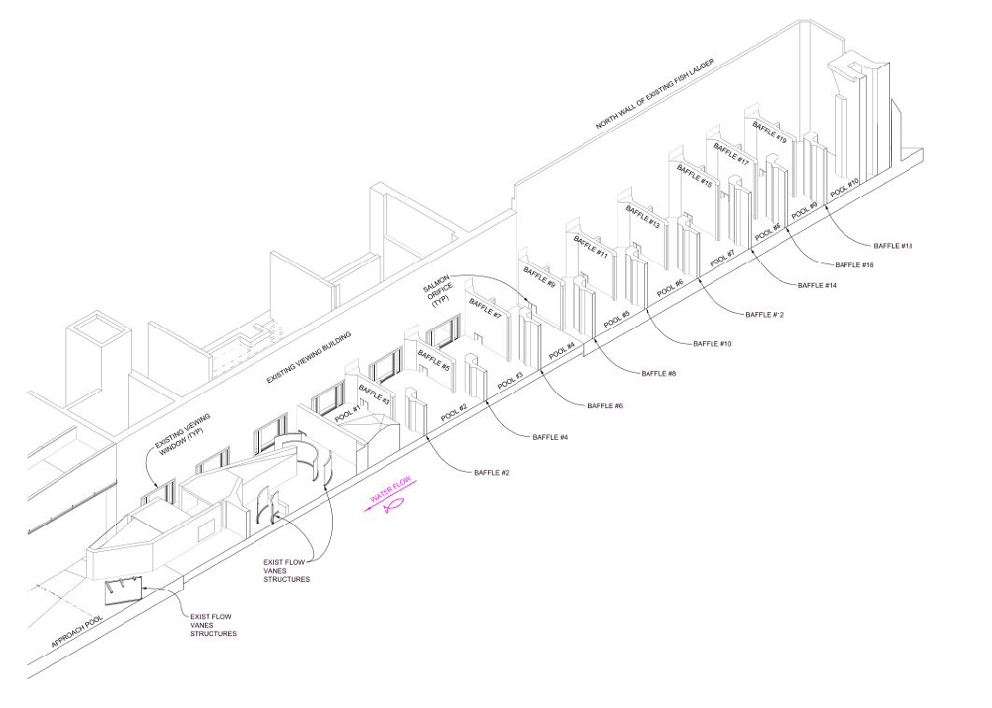

Fish Facility Design Review Work Group (FFDRWG)

USACE, Portland District

Project Update
Date Prepared/Updated: 2022-10-03

BON Second Powerhouse FGE
Project Identifier: | P2 #
Project Manager (PM): | Jim Adams (CENWP-PMF)  James.R.Adams@usace.army.mil
Technical Lead (TL): | Max Wilson-Fey (CENWP-ENC)  Max.P.Wilson-Fey@usace.army.mil
FFDRWG Coordination (FL): | Jon Rerecich (CENWP-PME)  Jonathan.G.Rerecich@usace.army.mil

Project Description
Steel plates were installed in all units in the A and B headgate slot to restrict flow in the gatewells to improve passage conditions for juvenile fish. During routine inspections, however, it became apparent that the anchoring system for the steel plates was inadequate. In effect, the nuts and anchoring bolts holding down the plates had come loose, posing the risk that the plates could detach and potentially take out a unit. All steel plates were removed from the units. A concrete corbel has been installed in Unit 15 where the steel plates once were. The design goal is to achieve similar gatewell hydraulic conditions as the steel plates. This new concrete corbel has been designed to meet the flow criteria established and tested for the previous steel plates to meet the hydraulic and biological goals.

Project Schedule
CLIN | Status | Description | Award/Exercise Date | Construction Execution Window
1 | Mandatory | Mobilization/Demobilization | Awarded DEC 2020 | Complete
2 | Mandatory | Unit 15 Construction | Awarded DEC 2020 | Complete
3 | Optional | Second Mob/Demob, Unit 11 and 18 Construction | Awarded AUG 2021 | DEC 2022 - FEB 2023
4 | Optional | 2 Additional Units | Awarded AUG 2021 | Extend through MAY 2023
5 | Optional | 2 Additional Units | Awarded AUG 2021 | Extend through AUG 2023
6 | Optional | 1 Additional Units | Awarded AUG 2021 | Extend through FEB 2024

Current Status
- 2022 hydraulic testing is complete. Velocity measurements were taken in unit 15 upstream of the VBS to verify performance of corbels. Pressure transducer measurements were taken in units 14 and 15 to determine effects of pressure wave on corbels.
- Preliminary data is under review by the Corps. Internal discussions continue to occur to discuss results and get alignment on recommended path forward. A final report is due 28-OCT-2022.
- Preliminary data suggests the 2022 data (corbels) displays slightly higher through-screen velocities compared to the 2015 data (steel plates). Average turbulence values were comparable between years. Pressure results show no appreciable impact of pressure wave on corbel.
- PDT moving forward at present time with outfitting the remaining units. Construction of corbels in units 11 and 18 is scheduled for the DEC 2022 – FEB 2023 IWW, followed by the remaining PH2 units throughout the remainder of 2023.

Topics for FFDRWG Review/Coordination

Fish Facility Design Review Work Group (FFDRWG)
USACE, Portland District
Project Update
Date Prepared/Updated: 2022-08-31

TDA Backup AWS Debris Management EDR
Project Identifier: | P2 #
Project Manager (PM): | Erin Kovalchuk (CENWP-PMF)  Erin.H.Kkovalchuk@usace.army.mil
Technical Lead (TL): | Mehdi Roshani (CENWP-ENC)  Mehdi.Roshani@usace.army.mil
FFDRWG Coordination (FC): | Jon Rerecich (CENWP-PME)  Jonathan.G.Rerecich@usace.army.mil

Project Description
This project is to evaluate alternatives to remove debris from The Dalles Dam Auxiliary Water Supply (AWS) trash rack. Debris build-up on the rack currently causes high head differential across the rack. Fish Unit Rehab requires the AWS backup system to operate during the rehab to provide adequate flow for fish attraction. Fish Unit Rehab duration is one year per unit for a total of two years. Long term use of the backup AWS system will be part of the alternatives evaluation.

Project Schedule
Milestone | Start | End
Criteria and Constraint Report (30%) | 4/19/2021 | 8/6/2021
Value Management | 8/9/2021 | 8/20/2021
Alternative Evaluation Report (60%) | 8/23/2021 | 1/27/2023
Draft Final Report (90%) | 1/30/2023 | 7/14/2023
ATR | 7/7/2023 | 7/21/2023
Final Report | 7/17/2023 | 10/23/2023
Closeout | 10/24/2023 | 10/30/2023

Current Status
- Working toward 60% EDR. The PDT has developed alternatives, evaluation criteria and scoring.
- The 50% EDR and alternatives ranking matrix are available on the FFDRWG website: http://pweb.crohms.org/tmt/documents/FPOM/2010/FFDRWG/2022%20FFDRWG/
- The PDT is planning to present the alternatives at the Oct. 6 FFDRWG for discussion.

Topics for FFDRWG Review/Coordination
- Discussion of alternatives and other ideas to incorporate into the evaluation matrix for the 60% Engineering Design Report (EDR) milestone.
- PDT will send the 60% EDR for FFDRWG review.

Summary
PDT stopped working on this project during alternative evaluation at the end of FY21, due to lack of funding. The Value Engineering (VE) study was performed in August 2021 and a draft report was provided. During the VE study, various tools were used to help the project team identify existing alternatives and develop new proposals to best meet project criteria. Weighted paired comparisons were used to develop performance criteria for ranking existing alternatives and new proposals. All proposals, as well as the team’s assessment of the top five existing potential alternatives, were evaluated against the performance criteria developed using the weighted paired comparisons.

After receiving the Draft VE Study Report, PDT further evaluated the weighted paired comparisons, prepared by the VE team, and updated the values and the evaluation criteria list. The PDT modified the alternative ranking of all the potential alternatives and the selected new potential alternatives proposed by the VE team. The EDR includes Evaluation Criteria, Paired Comparisons, and Alterative Rankings developed by both VE team and PDT members.

Fish Facility Design Review Work Group (FFDRWG)

USACE, Portland District

Project Update
Date Prepared/Updated: 2022-10-03

JDA Ladder Cooling
Project Identifier: | P2 # N/A
Project Manager (PM): | N/A
Technical Lead (TL): | N/A
FFDRWG Coordination (FC): | Scott Fielding (CENWP-PME)  Scott.D.Fielding@usace.army.mil

Project Description
Future project to reduce entrance-exit temperature differentials and maximum temperatures in the John Day South fish ladder. Ladder cooling structures at the Snake River dams are effective, a similar design may be effective at JDA as well.

Project Schedule (optimistic rough estimate)
YEAR | MAJOR ACTIVITIES
FY24 | EDR/DDR
FY25 | P&S (as needed; funding dependent)
FY26 | Construction (as needed; funding dependent)

Current Status

Temperature data has been collected for 2022. The next steps are adding the additional information (temperature data through September and during the shad operation) to the original memo. The memo will be sent to FFDRWG the week of October 17th with discussions about the memo and the path forward at the November FFDRWG meeting.

Topics for FFDRWG Review/Coordination
FFDRWG will review the above-mentioned memo at our 3-Nov meeting and determine if a structural solution is the best path forward to reduce the temperature differentials between the entrance and exit of the South Fish Ladder. If so, FFDRWG may recommend the Corps express capability for design and construction in an out-year’s budget.

